**Automatic recognition of electrical and architectural symbols using COSFIRE filters**



**Student**

Luke Agius

Student Number: 080358084

December 2012

**Supervisor**

George Azzopardi

**Programme**

BSc Creative Computing (Hons)

**Institute**

St. Martins Institute of IT (Malta)

Table of contents .

**1.Introduction****3**

**1.1** Choosing of project**3**

**1.2** Relevant modules**3**

**1.3** Supervisor**3**

**2. Aims and objectives****4**

**2.1** Research questions**4**

[**2.2** Deliverables](#_2.2_Deliverables_(How)**4**

**3. Methods****5**

**3.1** COSFIRE filters**5**

**3.2** Gabor filters**5**

**3.3** Protocol description**7**

**3.3.1** COSFIRE configuration**7**

**3.3.2** Shape descriptor**7**

**3.3.3** Testing**8**

**4. Project plan****9**

**4.1** Proposed project plan**9**

**4.2** Actual project plan**10**

**5. Progress to date****11**

**5.1** Literature review**11**

**5.2** Results so far**11**

**5.3** Progress as compared to project plan**12**

**6. Planned work****12**

**7. References****13**

# 1. Introduction

## 1.1 Choosing of project

Handheld devices have become ubiquitous due to their flexibility and enhanced productivity. Such devices allow users to write freely on them or to manually sketch symbols. The automatic recognition of handwriting and hand-drawn sketches is important to convert the manual input to a digital representation. Examples of applications include recognition of handwritten letters, digits, signatures, musical notes, electrical and architectural symbols, among others.

My research is focused on the recognition of architectural and electrical symbols. This is a topic of active research [11]. This research is motivated by my academic interest in visual pattern recognition rather than from my work experience.

In this work, we investigate the effectiveness of COSFIRE filters [5] for the recognition of electrical and architectural symbols. In their work [5], the authors demonstrated that COSFIRE filters can be configured to be selective for specified prototype patterns. COSFIRE filters have been effectively applied to the detection of vascular bifurcations, recognition of handwritten digits and detection and recognition of traffic signs in complex scenes.

## 1.2 Relevant modules

The implementation of this project requires transferable skills that are gained from various modules of the degree BSc Creative Computing (Hons). The following are the most relevant ones:

* CO1109 Introduction to Java &OOP
  + The principles that I have learnt in this module are easily transferable to MATLAB, therefore reducing the learning curve.
* CO2226 Software engineering, algorithm design & analysis
  + The software engineering skills obtained in this module will be very helpful for designing and implementing this project.
* CC227 Interactive Multimedia
  + This project is wrapped around a pattern recognition technique that can be applied to classify patterns in 2D images. Topics like Multimedia Information Retrieval are the most relevant topics.
* CO3310 Artificial intelligence
  + This project deals with automatic recognition techniques that provide machine (artificial) intelligence.
* CO3311 Neural networks
  + Neural Networks are classification techniques that can be used to categorize test data. In this project we classify (recognize) electrical and architectural sketched symbols.

## 1.3 Supervisor

I have been under the supervision of George Azzopardi since September 2012. He completed four years (Oct 2008 to Sep 2012) of PhD studies at the Johann Bernoulli Institute for Mathematics and Computer Science, University of Groningen, the Netherlands. He will defend his PhD thesis in April 2013. He carried out his studies under the supervision of Prof. Dr. Nicolai Petkov in the Intelligent Systems group. His research interests are in the field of visual pattern recognition including computational modelling of the visual system of the brain. In his studies, he published novel brain-inspired algorithms for machine vision applications, which among others; include contour detection, segmentation, feature detection, shape recognition and retinal image analysis [1].

George Azzopardi is now a full-time research innovator at TNO (Netherlands Organisation for Applied Scientific Research). He is also a part-time researcher with the Intelligent Systems group of University of Groningen [1].

# 2. Aims and objectives

## 2.1 Research questions

The following are the questions that we pose in this thesis:-

1. How effective are COSFIRE filters for the recognition of electrical and architectural symbols?
2. How robust are COSFIRE filters to noisy symbols?
3. How does the performance achieved by COSFIRE filters compare to other state-of-the-art methods?

The effectiveness of COSFIRE filters will be evaluated by numerous experiments which will be performed on various publicly available data sets [4]. The images in these data sets contain noise less and noisy symbols.

## 2.2 Deliverables

The deliverables are split in two. The first deliverable is the dissertation which will be organized as follows:

1. Introduction
   1. Problem definition
   2. Literature review of state-of-the-art methods
   3. A brief introduction of COSFIRE filters
   4. Highlighting the contribution of this work
2. Method
   1. Explanation of the configuration of COSFIRE filters by given prototype patterns
   2. Explanation of the application of COSFIRE filters to test images
   3. Explanation about forming a shape descriptor from COSFIRE filter responses
3. Experimental Results
   1. A description of data sets used
   2. A description about the design and running of experiments
   3. Reporting results
4. Discussion
   1. Analysis of the results
   2. A comparison to state-of-the-art methods
   3. Highlighting any limitations of COSFIRE filters
   4. Outlook
5. Summary and Conclusions
   1. The final chapter will first provide a summary of the entire dissertation and then we draw the conclusions

The second deliverable will be the MATLAB implementation along with documentation on how it is built. This will include a step by step guide on how to re-run the experiments.

The literature review will provide me a better understanding of state-of-the-art methods and through the MATLAB implementations I will address the posed questions by various experiments. The process of implementing a dissertation through the mentioned deliverables will also allow me to gain experience of a research process.

# 3. Methods

The research method applied in this project is quantitative. This also includes data analysis and hypothesis testing. Through the application of COSFIRE filters and classification techniques on publicly available data sets we are going to compute performance measurements in the form of true positives & false positive rates which can be used to derive accuracy, precision and recall rates.

The data sets that we use have different levels of complexity due to noise, deformation, rotation and scaling. The following is the approach that we adopt. We start by evaluating the proposed method on the data set with the least level of complexity which contains noiseless test images given in the same orientation and scale of their corresponding models. Then we apply the method to the data set with the second lowest complexity and finally we evaluate the COSFIRE filters on the data set with the highest level of complexity. The mentioned order in which we run experiments facilitates the analysis of the performance results and give us insight on further tuning the method.

In the remaining parts of this section we give a brief explanation on the actual COSFIRE method that we will be using to automatically recognize electrical and architectural symbols.

## 3.1 COSFIRE filters

COSFIRE filters are effective for keypoint detection and pattern recognition. They are trainable because they can be configured with any given prototypes. They are constructed by a configuration process which automatically analyses the dominant orientations and their mutual spatial arrangement of a given prototype pattern of interest [5]. We use Gabor filters to detect the dominant orientations. The response of a COSFIRE filter is computed as the weighted geometric mean of the involved Gabor filter responses. This means that a response is only achieved when all the concerned contour parts are present [5].

## 3.2 Gabor filters

A one dimensional Gabor function is defined as the multiplication of a sinusoid with a Gaussian window as shown Fig. 3.2.1. Gabor functions have then been extended to two-dimensions, as the product of an elliptical Gaussian and a sinusoid plane wave [14]. Fig. 3.2.2 illustrates a Gabor function map that is tuned for vertical bars.

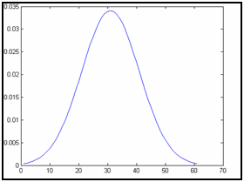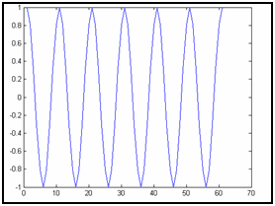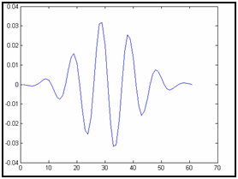

**=**

**X**

**Fig. 3.2.1:** (a)A one dimensional Gabor function is the product of a (b) Gaussian function and a (c) cosine function.

**(a)**

**(b)**

**(c)**

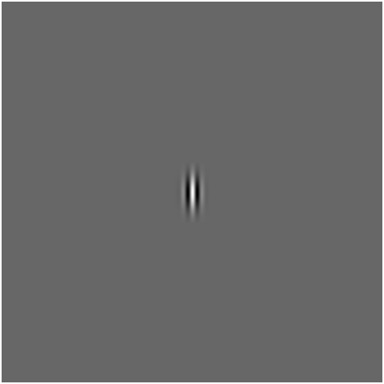

**Fig. 3.2.2:** (a)A two dimensional Gabor function is the product of an (b) elliptical Gaussian and a (c) complex plane wave.

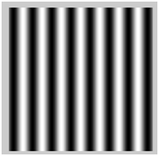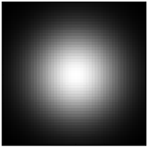

**=**

**X**

**(a)**

**(b)**

**(c)**

In their research Jones and Palmer [13] demonstrated that two dimensional (2D) Gabor functions, which were proposed by Daugman [14], can be used to model receptive fields of the orientation-selective simple cells of cats. Fig. 3.2.3 shows the similarity between two dimensional Gabor functions and receptive fields of cats’ simple cells. The top row shows 2D receptive field profiles while the second row shows their corresponding best fitting Gabor functions [8].



**Fig. 3.2.3:** (First row) The receptive field profiles of some cells in a cat’s visual cortex compared to their corresponding best fitting (second row) two dimensional Gabor functions. Adapted from [8].

Daugman’s research [14] enabled the use of Gabor functions in computer vision applications as means to analyse images [15]. Recently, a novel CORF (Combination of Receptive Fields) computational model was proposed in [10]. The authors demonstrated that the CORF model exhibits more properties that are typical of simple cells than the Gabor function model. The CORF model also achieves better performance in contour detection tasks.

## 3.3 Design of experiments

We use the publicly available data sets that are provided for GREC contests [4]. These data sets are organized into three categories.

The first category consists of 24 data sets. Each data set contains a number (varying between 25 and 150) of different electrical and architectural symbols each represented by a single image. These data sets contain 1000 test images of deformed symbols of increasing complexity. For instance, the least complex data set contains images that are only slightly deformed, while the most complex data set consists of images of symbols with the highest deformation.

The second category consists of seven data sets, each comprising 150 different symbols. Besides deformation, these data sets also contain images of geometrically transformed symbols, such as different orientations and scale.

The last category contains three data sets. They contain large number of different model symbols and large number of test images that combine different degradation levels and different transformations.

The way we evaluate COSFIRE filters for these data set is as follows. In Section 3.3.1 we give a brief overview of how we first configure COSFIRE filters in a training phase. Then, in Section 3.3.2 we explain how we form shape descriptors from the responses of these filters. Finally, in Section 3.3.3 we explain we use the resulting feature vectors to classify test images.

### 3.3.1 COSFIRE configuration

We configure a COSFIRE filter for every model symbol in a given data set. This is achieved by choosing the center of the given image and consider a number of concentric circles around it. The configuration process, which is thoroughly explained in [5] automatically analyses the prototype pattern and extracts information about the dominant orientations and their mutual spatial arrangement. This information defines the concerned COSFIRE filter. Fig. 3.2.1.1 shows the configuration of one symbol model.

**(b)**

**(a)**

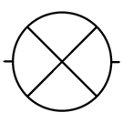

**Figure 3.3.1.1:** (a) A symbol model taken from a data set in the first category namely #3 [4]. (b) Configuration of a COSFIRE filter to be selective for the symbol in (a). Here we use four concentric circles. The chosen number of concentric circles is not intrinsic to the method but rather to the complexity of the given prototype pattern of interest.

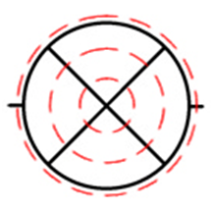

### 3.3.2 Forming a shape descriptor

We define a shape descriptor as follows. For a given image we apply the COSFIRE filters one by one. From the response image that is achieved by every COSFIRE filter we only take the maximum value. This means that a given image is described by a vector of values with a size that is equivalent to the number of COSFIRE filters used.

COSFIRE filters

Symbol

**Figure 3.3.2.1:** A row *i* represents the feature vector of a symbol model composed of the maximum responses of COSFIRE filters. Element *j* of a feature vector *i* is the maximum response of a COSFIRE filter which is configured by model symbol *j*

0

1

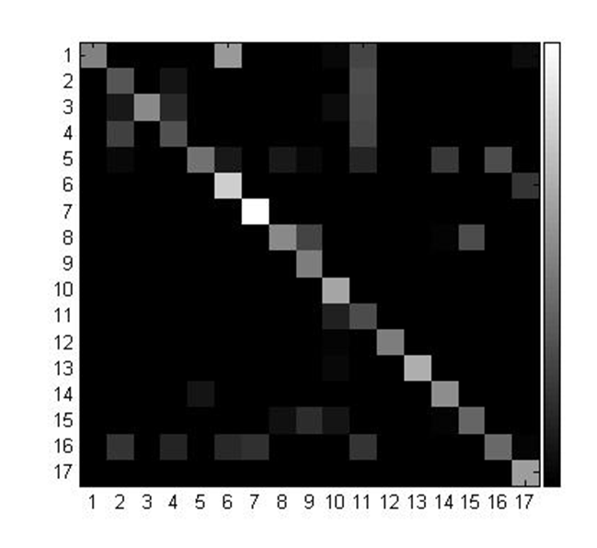

Fig. 3.3.2.1 shows the feature vectors of 17 model symbols. The diagonal values are the maximum responses that are achieved by COSFIRE filters that are configured by the corresponding model symbols.

### 3.3.3 Testing

First, we apply the above mentioned shape descriptor to each test image, such that the given images are described by feature vectors. Then, these vectors are classified using a k-nearest neighbour (KNN) classification technique by computing the Euclidean distance to each training feature vector. A test vector is then classified to the symbol for which the Euclidean distance is the smallest.

# 4. Project plan

## 4.1 Proposed plan

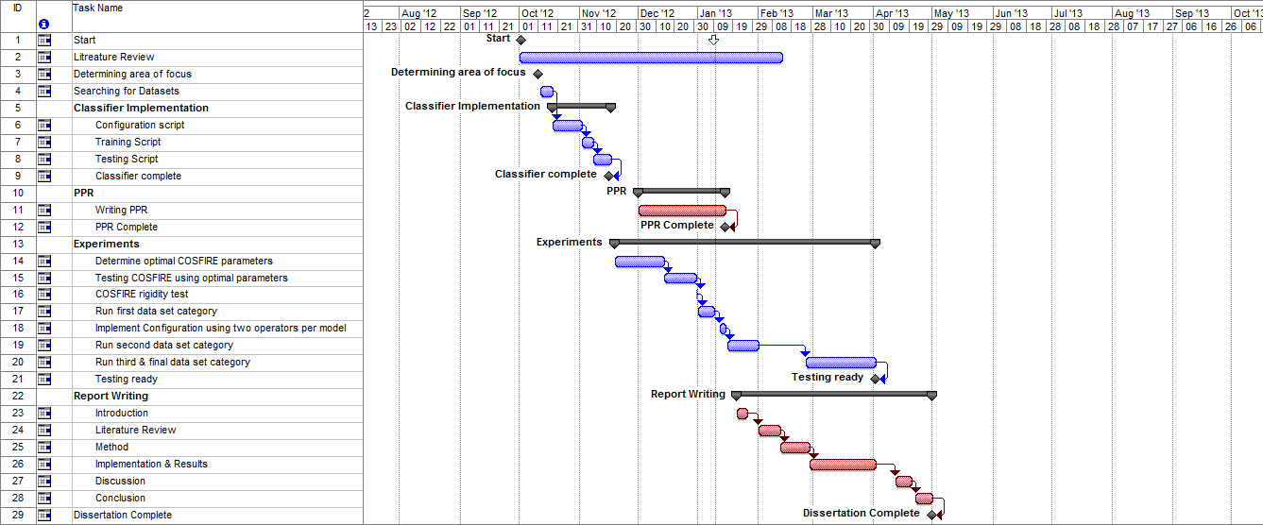

## 4.2 Actual plan

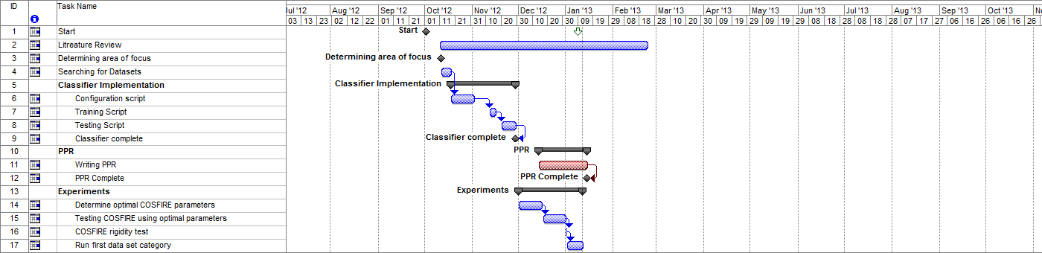

# 5. Progress to date

## 5.1 Literature review

Since my area of focus is the recognition of electrical and architecture symbols, I first reviewed the paper titled “Report on the Symbol Recognition and Spotting Contest” [4]. It focuses on reporting the results attained during symbol recognition GREC contests using various recognition approaches based on shape matching techniques. Then, I studied the methods that have already been applied in this contest [4]. Furthermore, I have also reviewed shape matching and recognition methods using shape context [12] and COSFIRE filters [5].

After doing so, I decided to use the recently introduced COSFIRE filters which have been demonstrated to be effective in various applications. COSFIRE filters are better described by the paper “Trainable COSFIRE Filters for Keypoint Detection and Pattern Recognition” [5].

We will eventually compare our results with the ones shown in Table 5.1.1 which are the global symbol recognition results reported in the contests [4]. These results were achieved using the third category data set described in Section 3.3.

Table 5.1.1 reports the results of four sets where each has an increasing number of model images and the same number of symbols per model. Each data set has a different number of test images, thus increasing the level of complexity. Set #4 differs from the previous three since the test images given among other contour patterns rather than being isolated.

|  |  |
| --- | --- |
| Test Name | Recognition Rate |
| Set #1 (50 Model images) | 94.76% |
| Set #2 (100 Model Images) | 91.98% |
| Set #3 (150 Model images) | 85.88% |
| Set #4 (Cropped model images, 36 model images) | 96.22% |

**Table 5.1.1:** Global results for symbol recognition tests in the GREC contests.

## 5.2 Results so far

Using the proposed method in various experiments, the first of three categories of data sets has been processed entirely. The first experiment, labelled as task 14 in the project plan, was done in order to find the most optimal COSFIRE filter parameters by using only 100 randomly chosen symbols. After finding the most optimal COSFIRE filter parameters an experiment (task 15) was conducted to test those parameters against data sets from the first category. A rigidity test (task 16) was also conducted to investigate how discriminative can COSFIRE filters be. In this test, the filter’s parameters were set up in such way that, it would only detect spatial arrangements which are very close to the given prototype point of interest.

Once the optimal parameters were confirmed another experiment was done (task 17), this time to process the entire first category of data sets. The results shown in Table 5.2.1 are the results achieved so far.

|  |  |  |  |  |
| --- | --- | --- | --- | --- |
| **Experiments on Data Sets from Category 1** | | | | |
| **#** | **Data Set** | **Results** | | |
| **True Positives** | **False Positives** | **Recognition Rate** |
| 1 | sketches25f-level1 | 1000 | 0 | 100% |
| 2 | sketches25f-level2 | 999 | 1 | 99% |
| 3 | sketches25f-level3 | 995 | 5 | 99.5% |
| 4 | sketches25-level1 | 1000 | 0 | 100% |
| 5 | sketches25-level2 | 1000 | 0 | 100% |
| 6 | sketches25-level3 | 997 | 3 | 99.7% |
| 7 | Sketches50f-level1 | 1000 | 0 | 100% |
| 8 | Sketches50f-level2 | 997 | 3 | 99.7 |
| 9 | Sketches50f-level3 | 989 | 11 | 98.9% |
| 10 | Sketches50-level1 | 1000 | 0 | 100% |
| 11 | Sketches50-level2 | 999 | 1 | 99% |
| 12 | Sketches50-level3 | 992 | 8 | 99.2% |
| 13 | Sketches100f-level1 | 1000 | 0 | 100% |
| 14 | Sketches100f-level2 | 996 | 4 | 99.6% |
| 15 | Sketches100f-level3 | 991 | 9 | 99.1% |
| 16 | Sketches100-level1 | 1000 | 0 | 100% |
| 17 | Sketches100-level2 | 999 | 1 | 99% |
| 18 | Sketches100-level3 | 992 | 8 | 99.2% |
| 19 | Sketches150f-level1 | 985 | 15 | 98.5% |
| 20 | Sketches150f-level2 | 986 | 14 | 98.6% |
| 21 | Sketches150f-level3 | 986 | 14 | 98.6% |
| 22 | Sketches150-level1 | 997 | 3 | 99.7% |
| 23 | Sketches150-level2 | 994 | 6 | 99.4% |
| 24 | Sketches150-level3 | 983 | 17 | 98.3% |

**Table 5.2.1:** Recognition results for the first category of data sets using COSFIRE filters.

## 5.5 Progress compared to project plan

So far all planned deadlines for experiments and documentation have been met with only slight changes. The actual project plan so far is illustrated in Fig. 4.2.1. Even though some delays have taken place, everything is on track and the next experiment (task 18) is in progress.

# 6. Planned work

Next, we will repeat the experiments of the first category by configuring more than one COSFIRE filter for each model symbol. Rather than using the center point, we will choose random locations to configure COSFIRE filters by the neighbouring contour parts of the selected locations. This means that the resulting shape descriptor will be a vector with more dimensions that have been used so far. It is expected that such an approach will improve the classification results. From these results, we will analyse which is the optimal number of COSFIRE filters per symbol so that the same approach can be applied for the evaluation of the second and third categories of data sets.

# 7. References

**[1]** Azzopardi G, Main Page. Available from: <http://www.cs.rug.nl/~george/>. [Accessed on 19/12/2012]

**[2]** Delalandre M, Sketched Symbols, Available from: <http://mathieu.delalandre.free.fr/projects/sesyd/symbols/sketches.html>. [Accessed on 15/11/2012]

**[3]** Delalandre M, International Symbol Recognition Contest 2011, Available from: <http://mathieu.delalandre.free.fr/projects/sesyd/symbols/isrc2011.html>. [Accessed on 15/11/2012]

**[4]** Valveny E, Delalandre M, Raveaux R and Lamiroy B, “Report on the Symbol Recognition and Spotting Contest”. *Revised Selected Papers of Workshop on Graphics Recognition (GREC), Lecture Notes in Computer Science (LNCS),* volume 7423, pp. 1–11, 2012.

**[5]** Azzopardi G. and Petkov N. “Trainable COSFIRE Filters for Key point Detection and Pattern Recognition”. *IEEE transactions on pattern analysis and machine intelligence,* volume 35, issue 2, pp. 490–503, 2012.

**[6]** Barina D. “Gabor wavelets in image processing”. *Proceedings of the 17th Conference STUDENT EEICT 2011, Brno, CZ, VUT v Brně*, pp. 522-526, 2011.

**[7]** Tai Sing L. “Image Representation Using 2D Gabor Wavelets”. *IEEE transactions on pattern analysis and machine intelligence,* volume 18, issue 10,pp. 959–971, 1996.

**[8]** Daugman J.G. “Complete discrete 2-D Gabor transforms by neural networks for image analysis and compression.” *IEEE Transactions on Acoustics, Speech, and Signal processing* *July 1988,* volume 36, issue 7, pp. 1169–1179, 1988.

**[9]** Kanungo T. Haralick R.M. Stuezle W. Baird H.S. Madigan D. “A statistical, nonparametric methodology for document degradation model validation”. *IEEE transactions on pattern analysis and machine intelligence* volume 22, issue 11*,* pp. 1209–1223, 2000.

**[10]** Azzopardi G. Petkov N., “A CORF computational model of a simple cell that relies on LGN input outperforms the Gabor function model”. *Biological Cybernetics,* volume 106, issue 3, pp. 177-189, 2012.

**[11]** Cordella L. P. Vento M. “Symbol recognition in documents: a collection of techniques” *International Journal on Document Analysis and Recognition,* volume 3, issue 2, pp. 73–88, 2000.

**[12]** Belongie S. Malik J. Puzicha J. “Shape matching and object recognition using shape contexts” *IEEE transactions on pattern analysis and machine intelligence,* volume 24 issue 4, pp. 509-522, 2012.

**[13]** J. P. Jones and L. A. Palmer, "An Evaluation of the Two-Dimensional Gabor Filter Model of Simple Receptive-Fields in Cat Striate Cortex", *Journal of Neurophysiology,* volume 58, issue 6*,* pp. 1233-1258, 1987.

**[14]** Daugman J. ‘’Uncertainty relation for resolution in space, spatial frequency, and orientation optimized by two-dimensional visual cortical filters”, *Journal of the optical Society of America,* volume 2, issue 7, pp. 1160-1169, 1985.

**[15]** J. G. Daugman, “Complete discrete 2-D Gabor transforms by neural networks for image analysis and compression,” *IEEE Transactions on Acoustics, Speech, and Signal Processing*, volume 36, issue 7, pp. 1169–1179, 1988.